CHAPTER IV

EXTERNAL INTERFACE REQUIREMENTS

In every system, the first thing that the user sees is the interface of the application. This chapter discusses the requirements for the external interfaces of the ASEAN Aid Map, which includes user, hardware, software, and communication interfaces. This part of the document gives thorough information about how the flow of the application. It also confirms that all external components are working in coordination with the application. This chapter shows the discussion of each interface for the users to understand the essential external requirement of the application.

1. User Interfaces

ASEAN Aid Map is a web application that has a purpose of strengthening and encouraging collaboration among NGOS in the Southeast Asian countries. This article discusses the actual appearance of the interfaces representing the different functions of the application. This section displays the user interfaces according to the decomposition chart. It contains the interface overview, functionality description, and the interface design. This section further discusses the different modules or interfaces that are about the functional requirements stated in the decomposition chart. The design of the different interfaces allows users to adapt to the environment of the application. In the following part, the user can imagine how the system looks like, and it serves as their guide in using the system.

1. Home Page for Public

This interface is the first thing that appears when the user enters the application. It contains the Aid map and at the bottom part are the lists of ongoing projects in the system. There is a search field where the user can find specific projects using keywords. Other than the search feature, the application also provides a filter option for the user to limit the results to either by project or organization. Figure 3 shows the Home page for public interface of the application.

*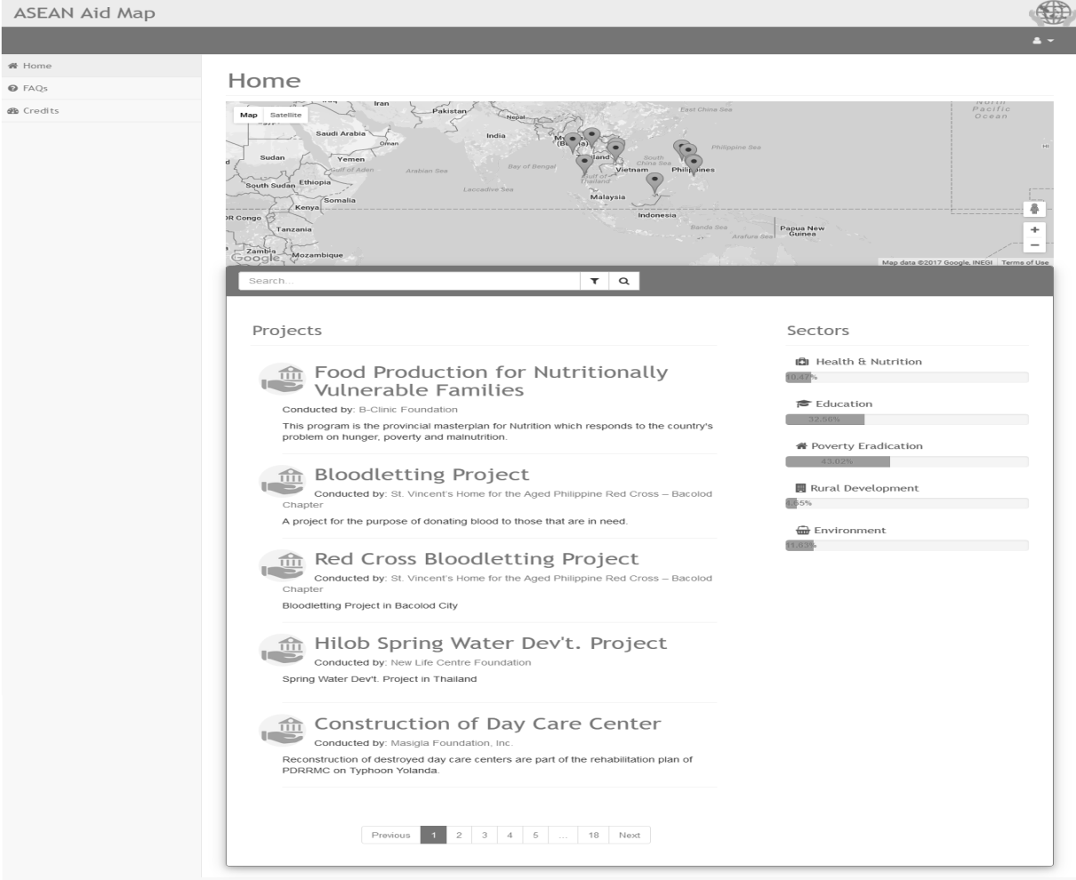*

Figure 3. Home Page for Public Interface.

1. Aid Map

This interface of the application displays the geographical information system feature. GIS is a computer system for saving, checking, and demonstrating data related to positions on Earth’s surface (National Geographic Society, 2016). This interface contains map markers that show the number of projects that is happening in the current location. There is also a zoom option provided which allows the users to zoom to the area. The user can also click on a specific marker on the map. Figure 4 shows the Aid Map interface of the application.

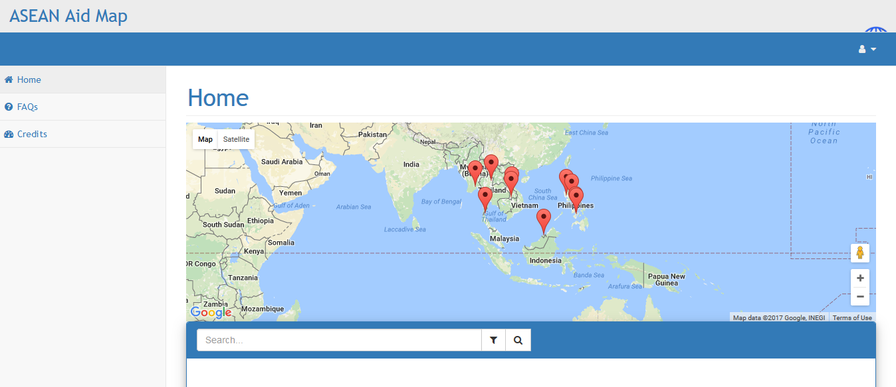

Figure 4. Aid Map GIS Interface.

1. Organization Profile for Public

This interface shows the content of the profile of the organization for the public. It displays the contact information and office address of the visited organization. The description tab presents a short and brief detail of what the organization is about and their purpose. The succeeding tabs contain information about the organization’s ongoing projects, the portfolio of projects, connection/s, awards and certifications, and their resources. Figure 5 shows the Organization’s Profile for the public of the application.

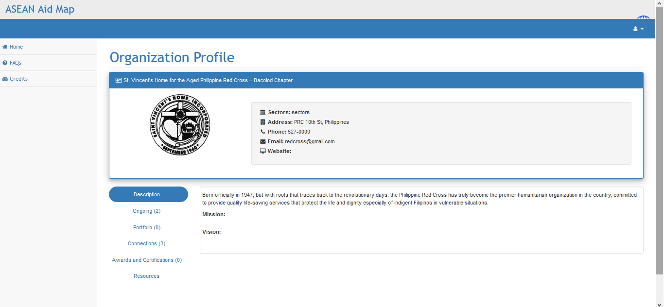

Figure 5. Organization Profile for Public Interface.

1. Project Profile for Public

This interface shows the profile of the selected project for the public. Some features are not available to the public view of this interface. Although some features are unavailable, this interface still provides relevant information for the visitors about a particular project. It shows the different aspects such as the timeline, budget, collaborator/s, and sector/s of the project together with its description, media center, and resources. Figure 6 shows the Project profile for the public interface of the application.

*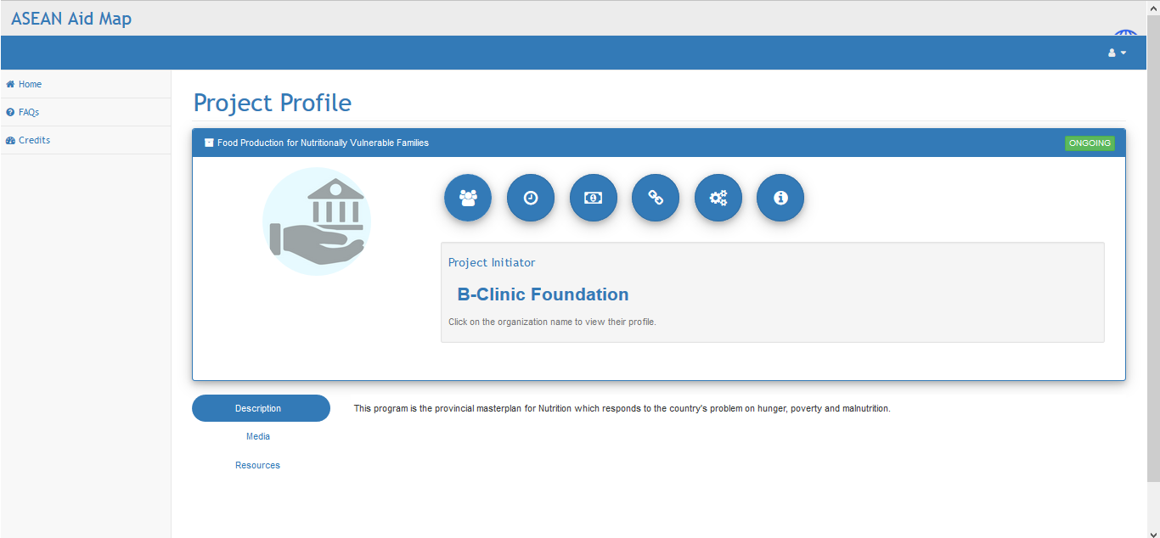*

Figure 6. Project Profile for Public Interface.

1. Sign-in

This interface displays the sign-in feature of the application. The sign-in feature serves as the gateway for registered users in the system. To authenticate and sign in to the application, the user must have an account and must input correct data in the fields provided. This interface also provides a sign-up link at the bottom to allow unregistered users to create their account. Figure 7 shows the Sign-in interface of the application.

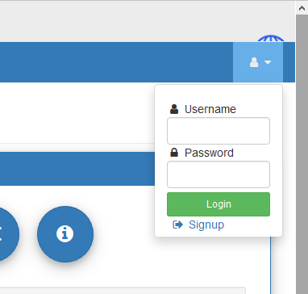

Figure 7. Sign-in Interface.

1. Create Account

This interface is for the creation of account of the unregistered organizations that want to use the application for their benefit. The application loads this interface after the user clicks the sign-up link in the sign-in interface. The interface displays fields that the user needs to fill up completely to create an account. The interface provides a create account button for the users to click to finalize the creation. Figure 8 shows the Create account interface of the application.

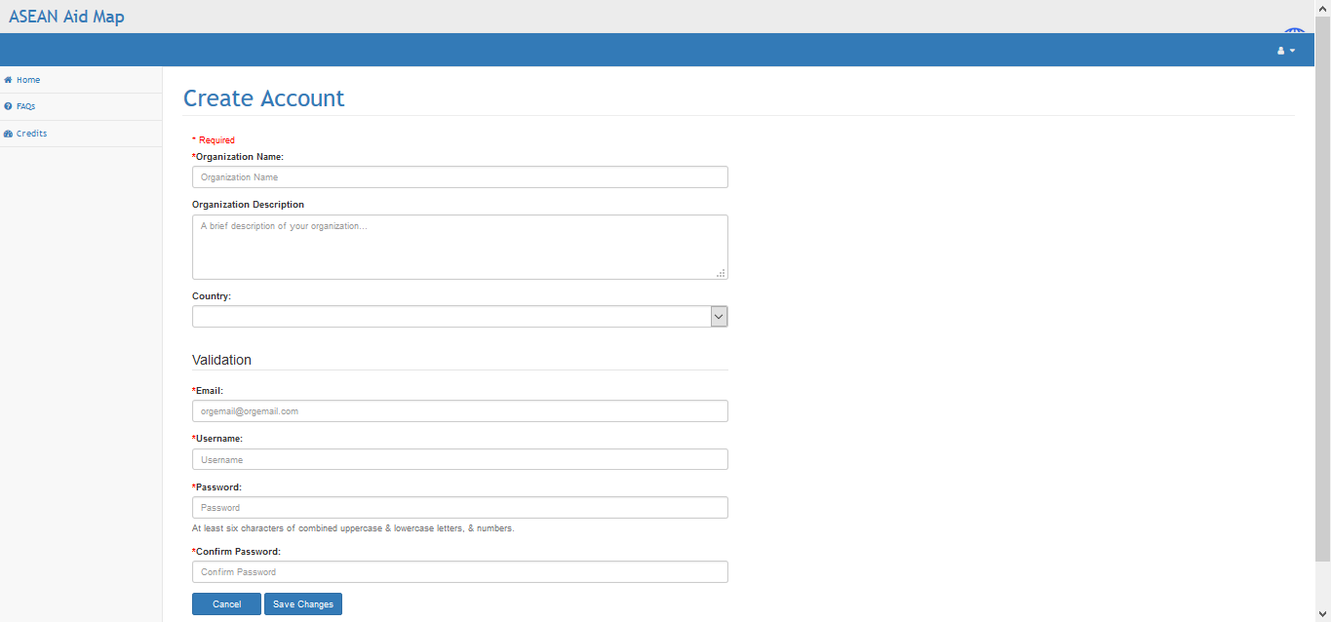

Figure 8. Create Account Interface.

1. Owner’s View to Organization Profile

This interface is for the owner of the account to see his/her profile. The interface is somehow the same as the public view but includes additional features that are not present to the other. The menu tab is different and in this interface, the application allows the owner to edit the profile of the organization by clicking the edit profile button. Figure 9 shows the owner view to organization profile interface.

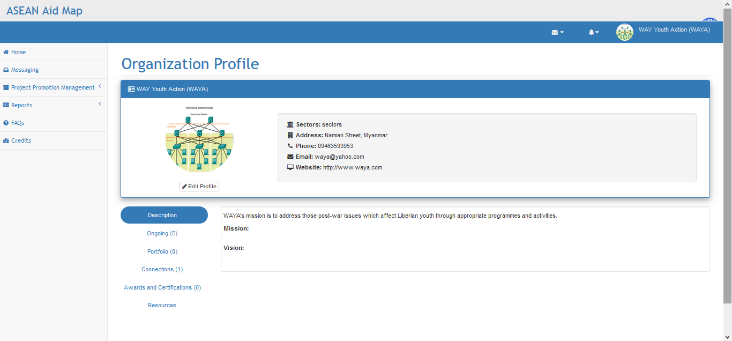

Figure 9. Owner’s View to Organizations Profile Interface.

1. Edit Profile

This interface is for the registered users to modify or commit changes to their created project. It provides the users the capabilities to edit their existing projects to provide updates or additional information about them. It can be accessed by clicking the Edit button on the profile of the project. This interface also provides the users to customize the display of information. Figure 10 shows the edit profile interface of the application.

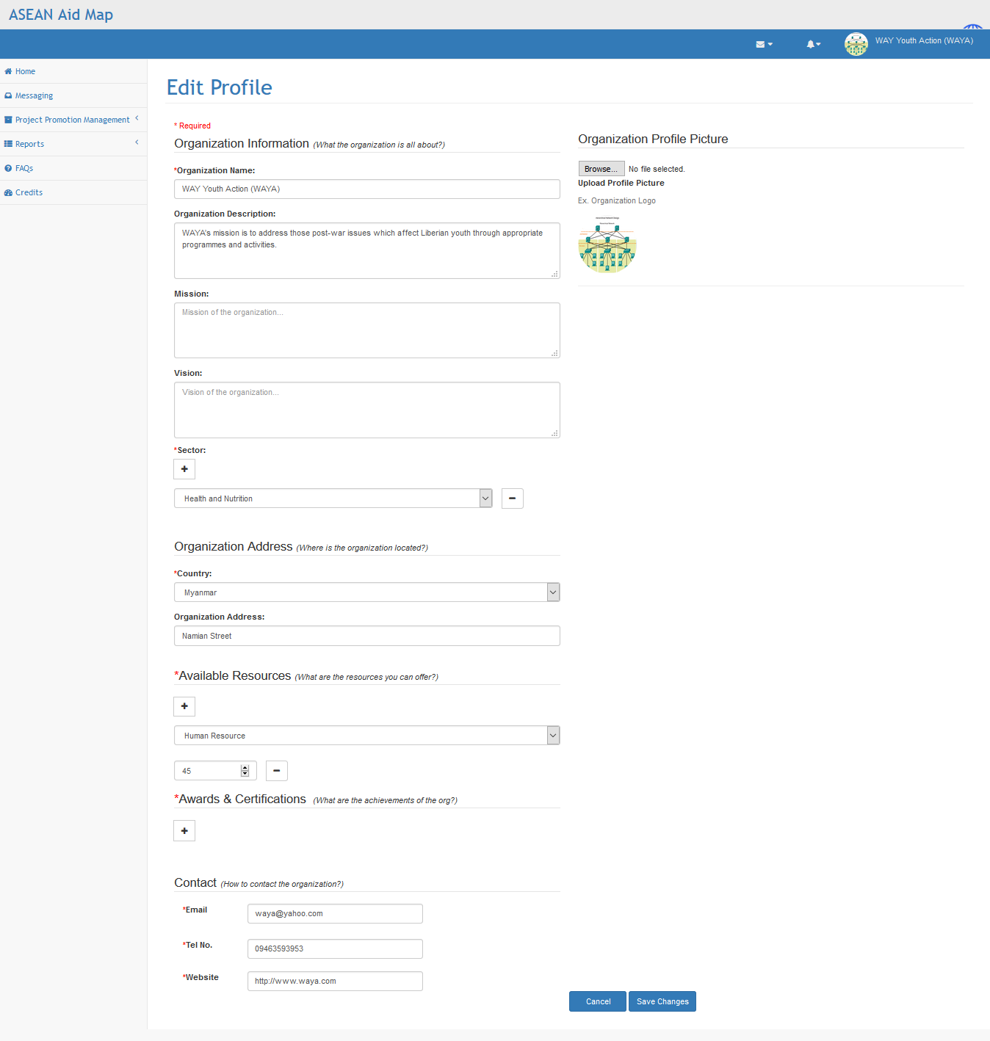

Figure 10. Edit Profile Interface of the Application.

1. Account Settings

This interface is for the registered users to edit their account information. It allows them to replace or change their email address, username, and password. There are fields corresponding to information that the user can edit to change the information of their account. The changes are committed if the user clicks on the save changes button in the interface. If the user clicks the cancel button, the changes are not committed, and the account information of the user stays the same. Figure 11 shows the account management interface of the application.

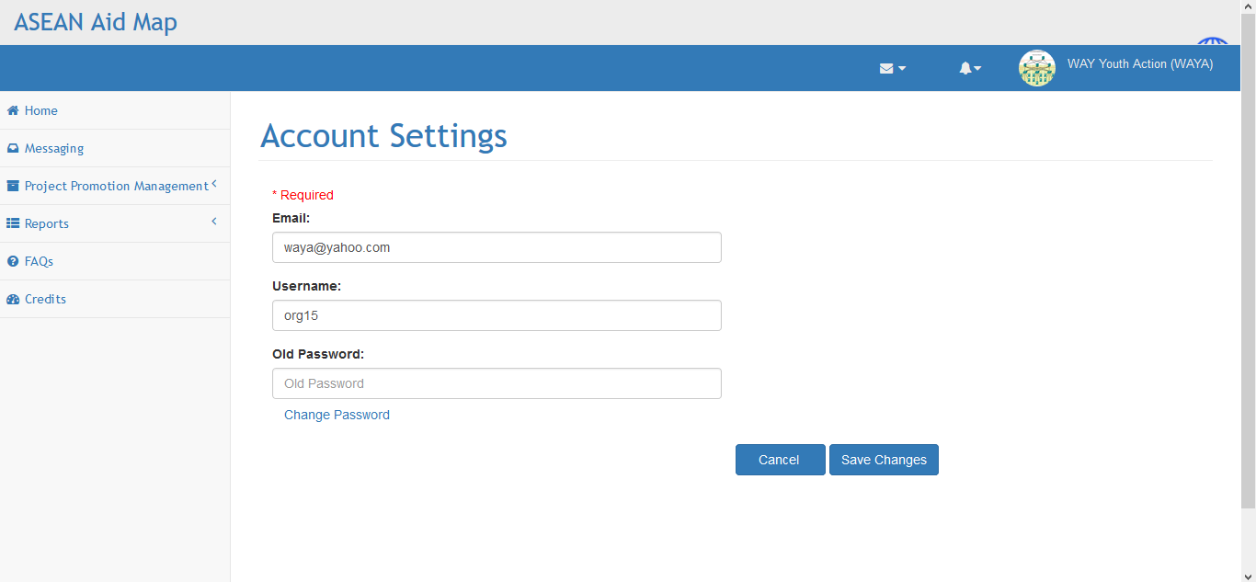

Figure 11. Account Settings Interface.

1. Registered Visitor’s View to Organization Profile

This interface is where other parties go if they want to know more about a particular association. The interface displays the name of the organization, picture, and other relevant information about it. The interface also provides an add connection button for the user to send partnership request to the group. Figure 12 shows the registered visitor’s view to organization profile interface of the application.

*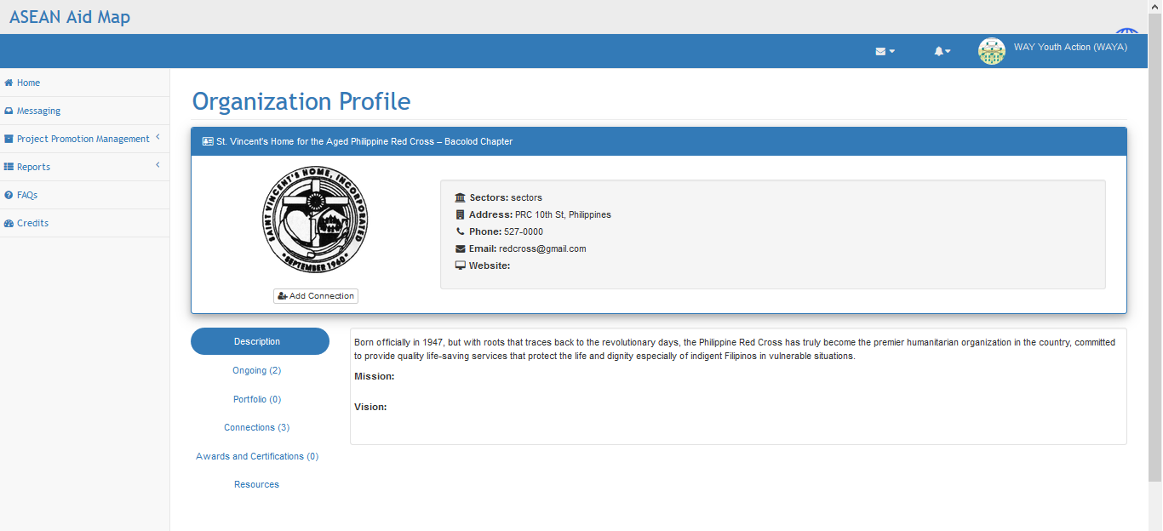*

Figure 12. Registered Visitor’s View to Organization Profile Interface.

1. Home Page for Registered Users

This interface is quite similar to the home page for public but has additional features and changes. The menu tab is different and is intended for registered users only. The interface also provides suggestions of projects on the right side which is not present in the public interface. The interface also contains the Aid map and the list of projects at the bottom. The search and filter feature is also present in this interface. Figure 13 shows the home page for registered users interface of the application.

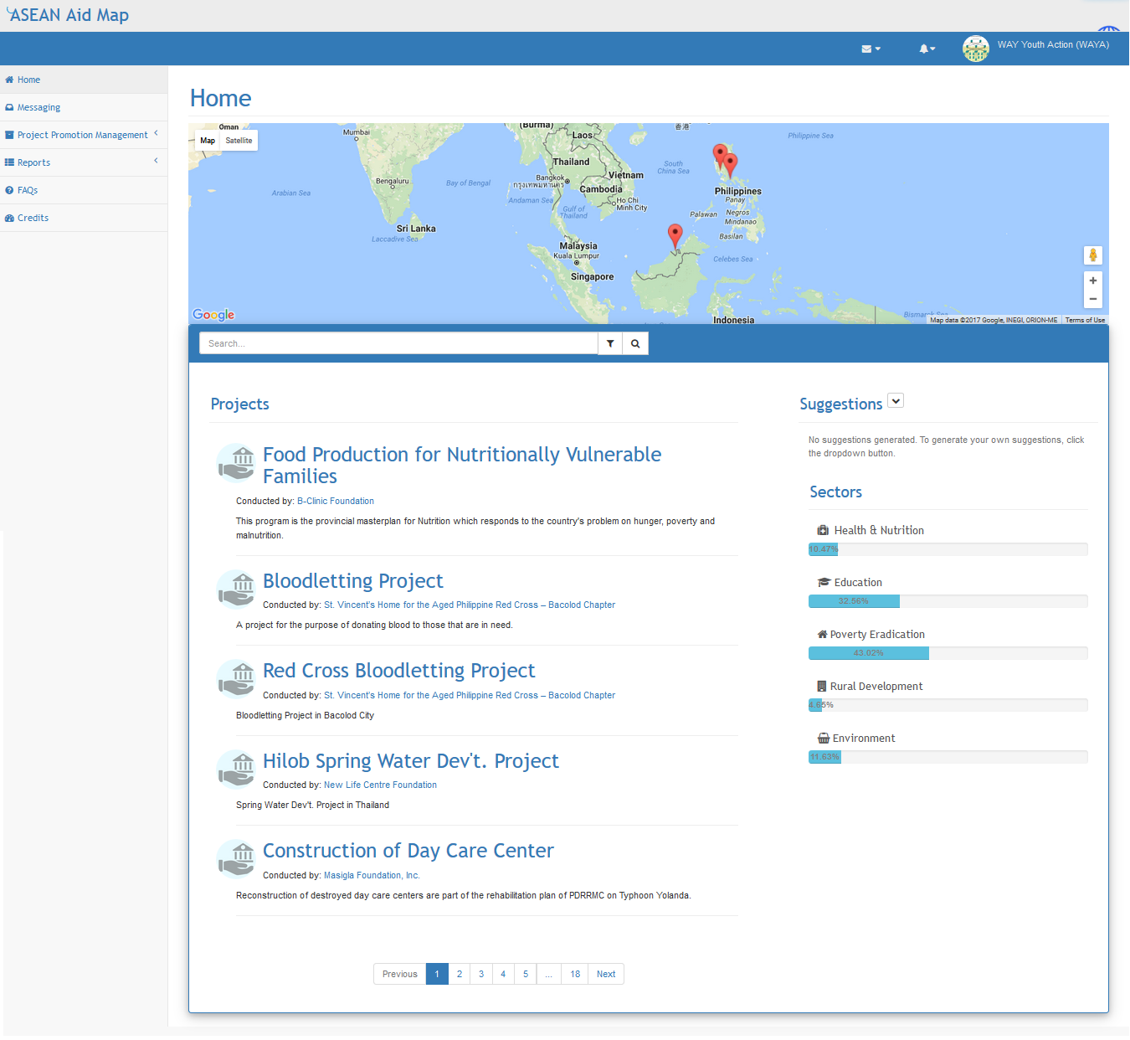

Figure 13. Home Page for Registered Users Interface.

1. Project List

This interface is for the registered users to view their initiated or on-going projects and collaborated projects. This interface can be accessed through the project promotion management tab. On the left part of the interface are the initiated projects that are created by the user. The right part contains the collaborated projects that the user is involved. Each project is a link that redirects to the profile page of the project. Figure 14 shows the project list interface of the application.

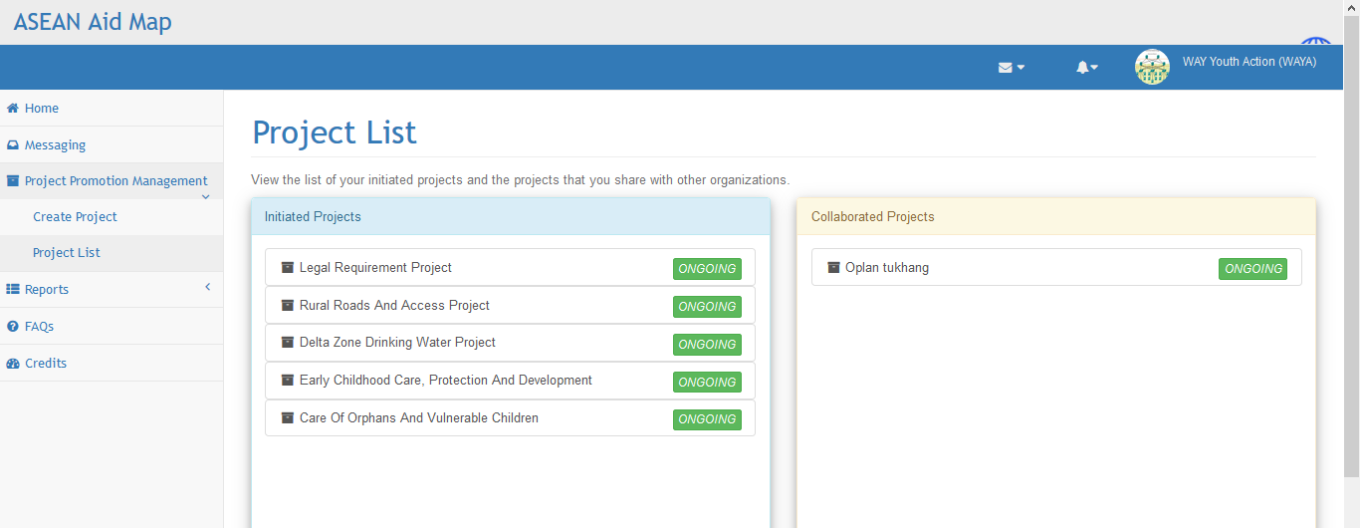

Figure 14. Project List Interface.

1. Create/Edit Project

This interface is for the registered users who are the organizations to create or edit their project. For the creation of the project, the interface is accessed through the project promotion management tab and clicking the create project. After creating the project, the users can edit them by clicking the edit project button in the profile of the project. Figure 15 shows the create/edit project interface of the application.

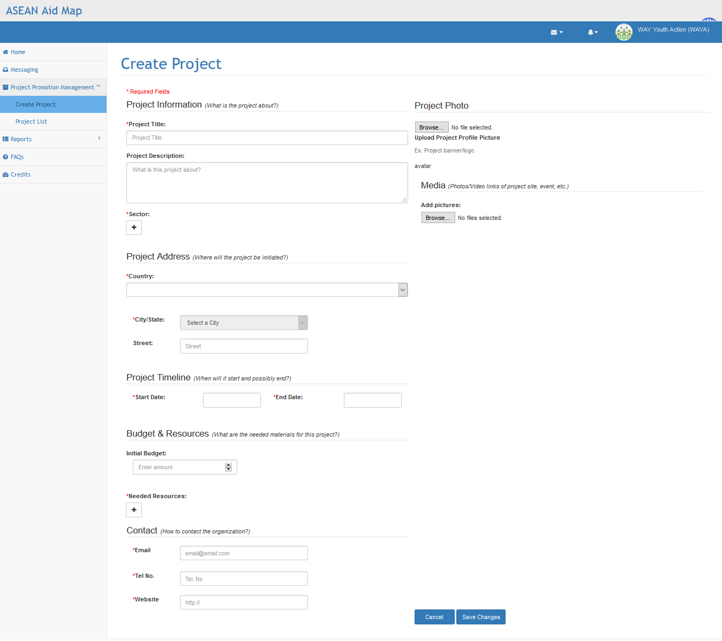

Figure 15. Create/Edit Project Interface.

1. Project Profile for Inviting Collaborator

This interface is for the owner or creator of the project to invite collaboration with connections. It is still in the project profile page but in the owner’s view. It has the edit project button for altering the project and invite collaborator button in the collaborators’ section. The user can request their connections for collaboration by clicking the invite collaborator button, and an invitation form is displayed. Figure 16 shows the project profile for inviting collaborator.

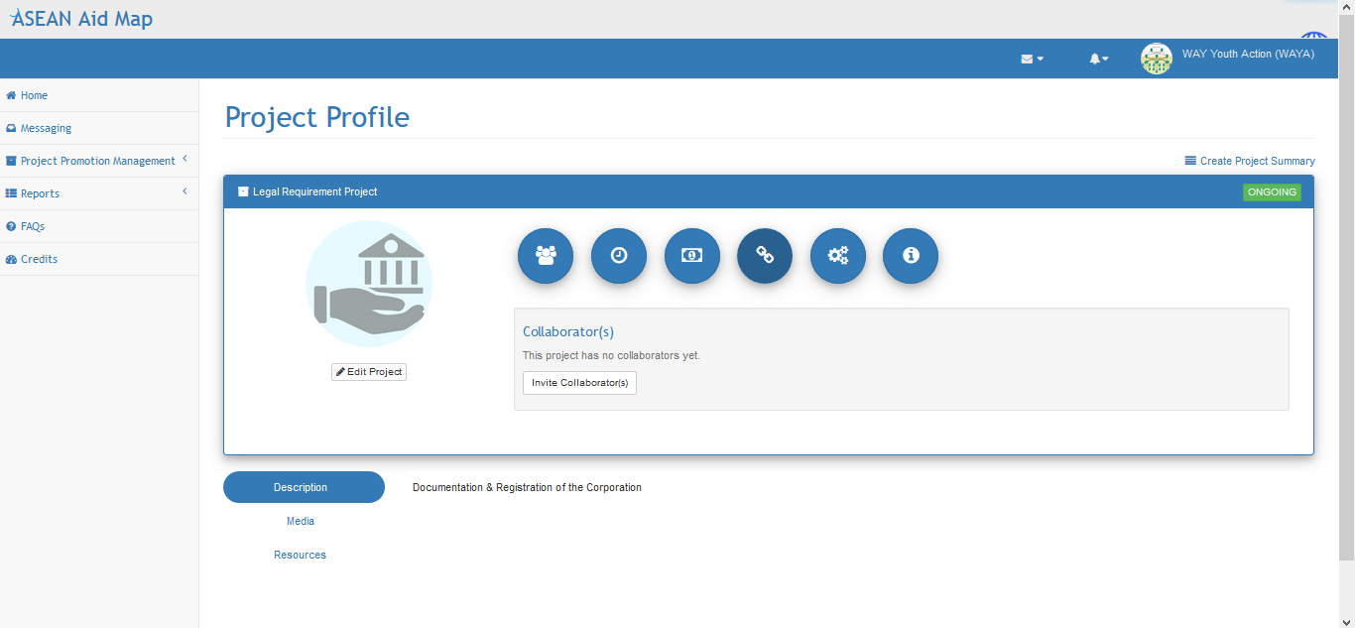

Figure 16. Project Profile for Inviting Collaborator Interface.

1. Invitation for Collaboration Form

Figure 17 shows the invitation for collaboration form of ASEAN Aid Map. This form is only accessible to the registered users of the application, specifically those who own a project and wants to invite other users to collaborate on that project. The users must first access the project profile page of their project and go to the Collaborators icon. As they clicked over the icon, they are able to see the "Invite Collaborators" button, and they must click it to open the form. The users fill out the form with the necessary information. Upon choosing the receivers of the invitation, the users can choose from the list of connections that they have, or they can also include those organizations in the suggested list.

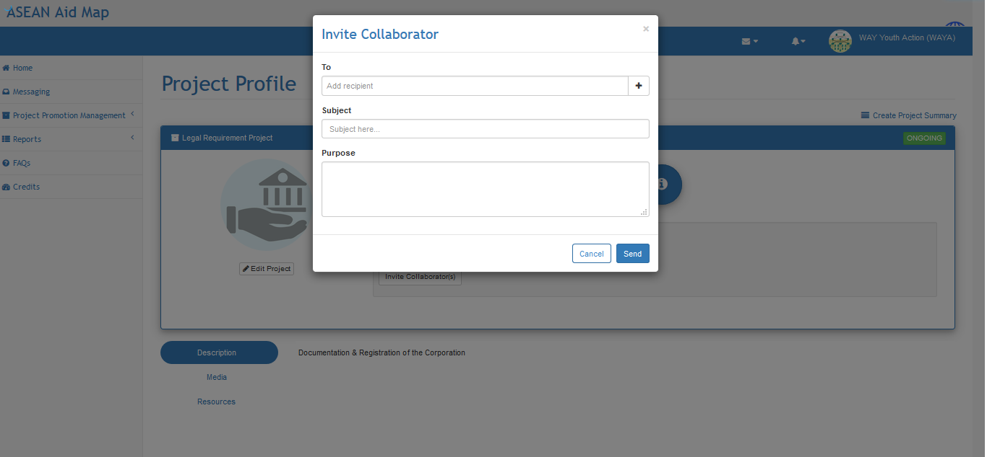

Figure 17. Invitation for Collaboration Form.

1. List of Organization in Invitation for Collaboration

This interface is for the registered users to add organizations that receive the invitation for collaboration if the request is submitted. The interface is a pop-up interface that appears after the user clicks the plus button in the “To” field of the invitation for collaboration form. It includes the list of organizations the users can invite as well as suggestions on the organizations that has the best match for them. The party is added to the recipients when the users click the Add button. The interface also includes a search field for the users to find the organization they are looking for easily. Figure 18 shows the list of organizations in the invitation for collaboration.

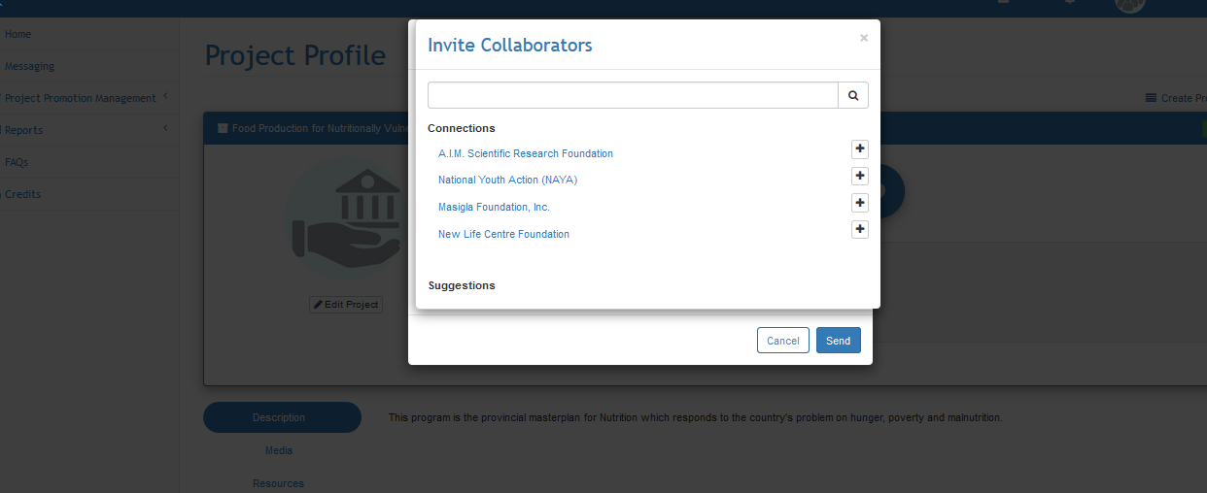

Figure 18. List of Organization in Invitation for Collaboration.

1. Project Profile for Applying for Collaboration

This interface is for the registered users to request for collaboration to the projects of their connections or other users. The interface provides an apply as collaborator button for the users to click to send an application request to the organization. Figure 19 shows the project profile for applying for collaboration.

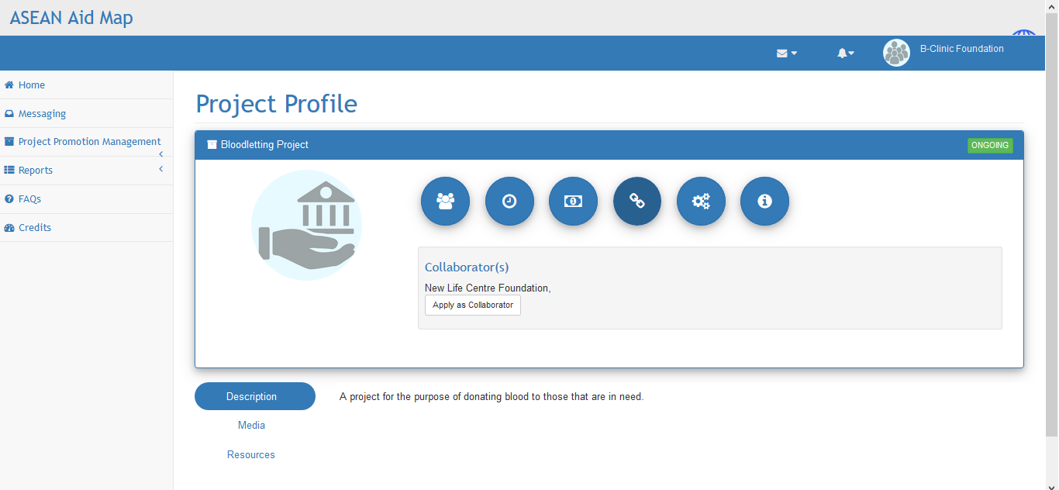

Figure 19. Project Profile for Application for Collaboration.

1. Application for Collaboration Form

Figure 20 shows application for collaboration form of ASEAN Aid Map. This form is only accessible to the registered users of the application. The users need to be in the Project Profile Page of the project that they want to have collaboration with and hover on the Collaborators icon. Then, the users need to click on the "Apply as Collaborator" and fill up the fields on the form. The subject area is the title of the application for collaborating, and the purpose field is for the reason why the organization wants to collaborate. The users must click on the Send button and wait for the response of the party leading that project.

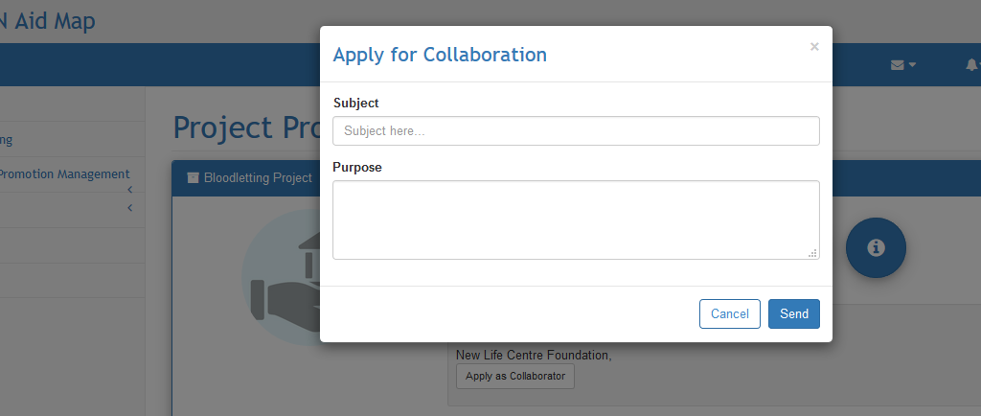

Figure 20. Application for Collaboration Form.

1. Notifications

This interface is for the registered users to view the notifications that they have received. The announcements include the connection requests, collaboration requests, new project creation from partners, and others. The user can accept or decline requests to this interface. This interface also collapses if the user clicks the notifications icon after opening it. Figure 21 shows the notifications interface of the application.

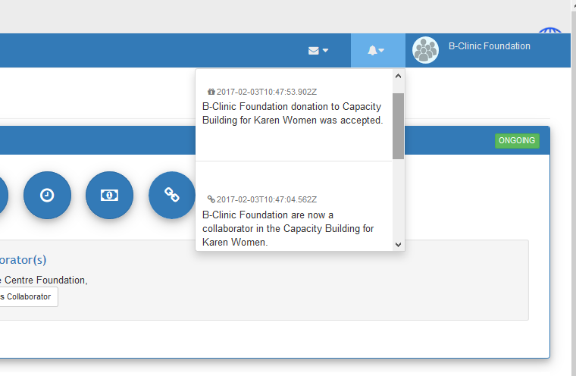

Figure 21. Notifications Interface.

1. Inbox

This interface is for the registered users to check the messages that they have received from their collaborated organizations. The interface is like a drop-down list that when the users click the icon, the list expands and displays its content which is the messages that the users have received. The users can view the substance of the message by clicking any portion of the message as long as it belongs to it. They can close the inbox by clicking again the icon which collapses back the drop-down list. Figure 22 shows the inbox interface of the application.

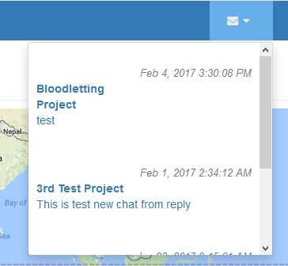

Figure 22. Inbox Interface.

1. Create Message

This interface is for the registered users to create new messages to their connections or collaborators’ group. The interface pops up when the user clicks the Create new message link in the inbox. The interface contains the recipient field which is a dropdown box that has an add button containing the connections and groups of the user. It also provides a field for the subject of the conversation and an area for the content of the message. The application sends the message if the user clicks the send button. Figure 23 shows the create message interface of the application.

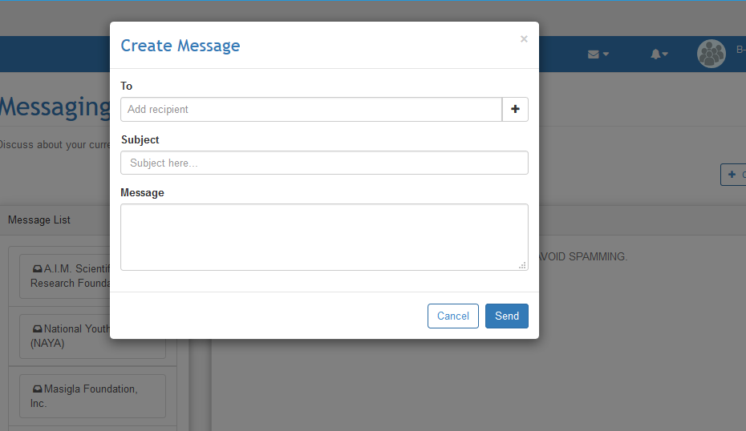

Figure 23. Create Message Interface.

1. Frequently Asked Questions

Figure 24 shows the frequently asked question interface (FAQs) in the Help Page of the application. Included on this page are the FAQs of the users. Both registered and non-registered users can view this page which seeks for help on how to use the application or to know other related information about the system. They can also submit their questions on this page when they cannot find their issues in the list of FAQs by clicking the submit a question button situated at the right part of the interface.

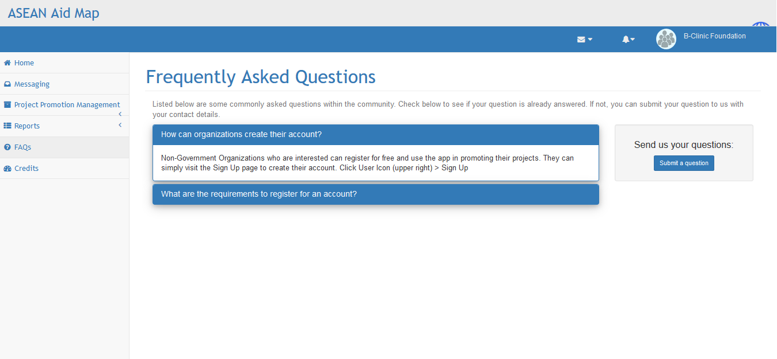

Figure 24. Help-Frequently Asked Questions Interface.

1. Question Form

Figure 25 shows the question form of the application. This form is shown when you click the submit question button on the Help Page. When the users want to ask a question or report a bug that they have found in the application, they can use this form to report it. The form can be accessed in the Help section of the application. The modal form closes if the user clicks the cancel button. The question is submitted if the user clicks the send button. The application sends the questions of the users to the email of the developers. The questions are answered by the developers and are added to the list of FAQs.

*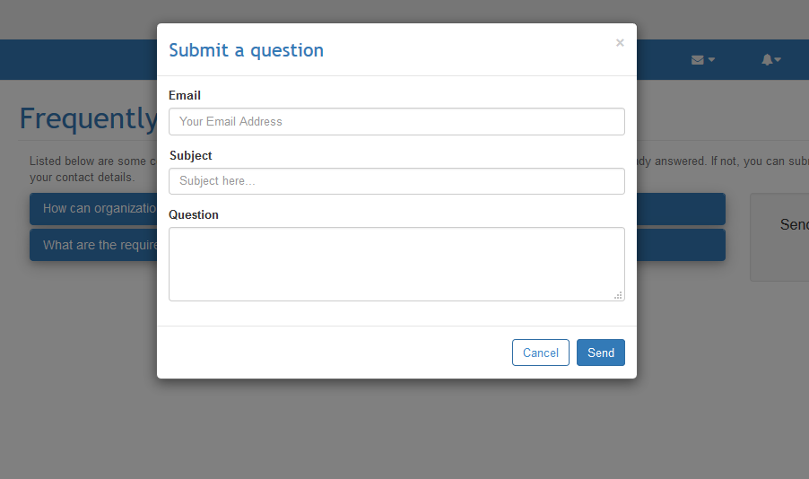*

Figure 25. Question Form Interface.

1. About The Developers

This interface dedicates itself for the information of the developers of the application. It contains the reason for the developers in creating the said application. This interface also displays the contact information of the developers of the proposed application like their e-mail addresses. This way, the users of the application can contact them directly for questions or concerns that are not adequately dealt with in the FAQs module. This interface is under the Help module of the application together with FAQs. Figure 26 shows the about the developers interface of the application.

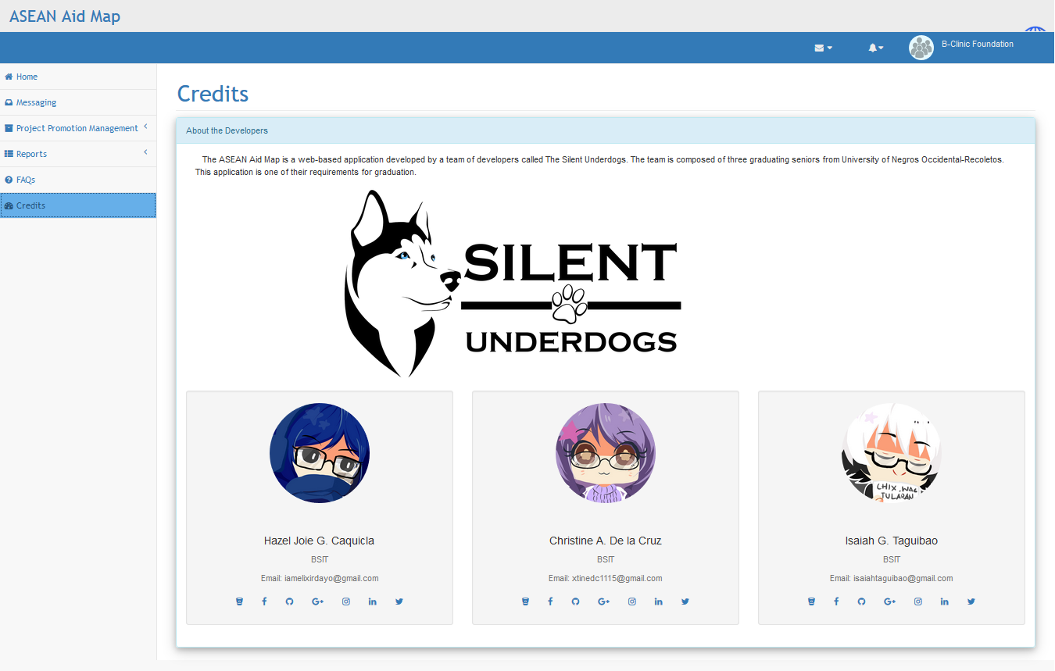

Figure 26. About the Developers Interface.

1. Project Frequency Report

This frequency report allows users to select a year and a sector to filter the results shown at the bottom part of the interface. The result indicates how numerous the projects are in a specified sector. This report can help in the decision making of the owner of the organization when it comes to what type of projects they might initiate in the future. Only registered users can access this report, and it is recommended that the users must have projects for the generation to be operative. Figure 27 shows the project frequency report interface of the application.

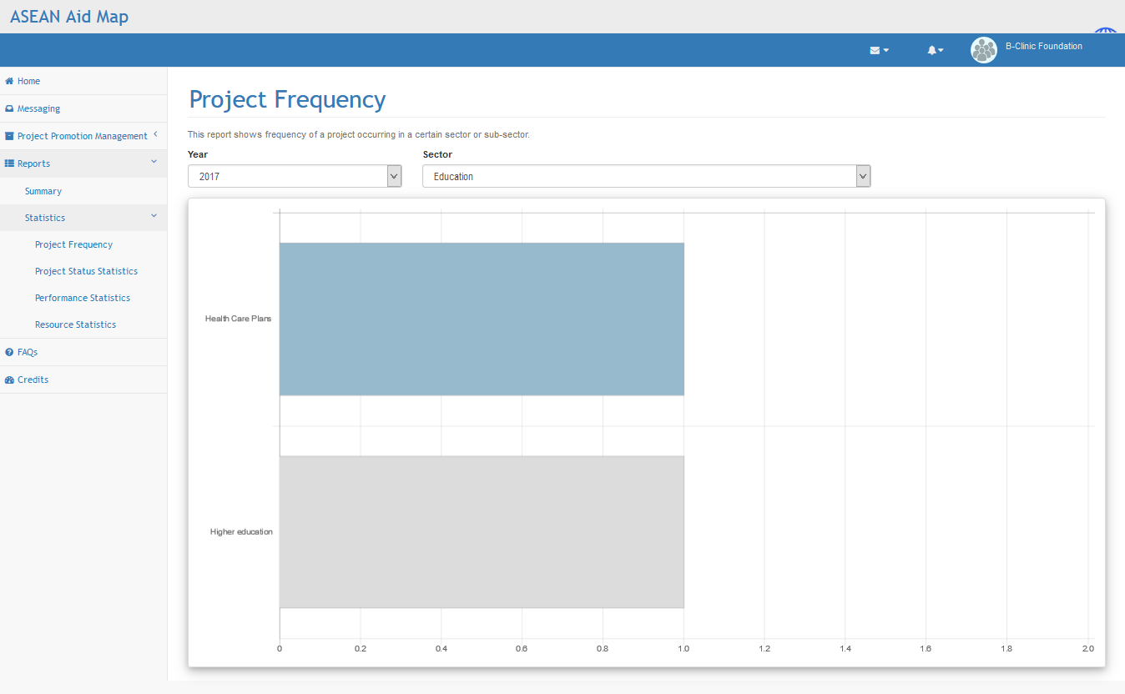

Figure 27. Project Frequency Report Interface.

1. Project Status Report

This report also allows users to filter results based on year and type of project, which is either initiated or collaborated by the users. This statistic report shows the number of projects in each status. The status of the number of projects can either be cancelled, completed, ongoing, or on-hold. Only registered users can also access this report, and it is recommended that the users must have projects for the generation to be operative. Figure 28 shows the project status report interface of the application.

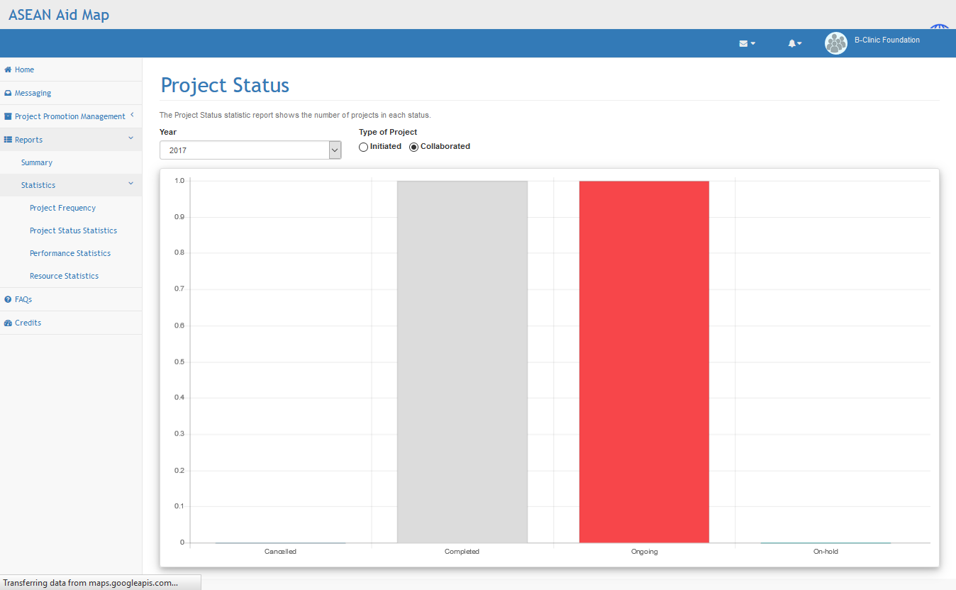

Figure 28. Project Status Report Interface.

1. Evaluation Form

This form displays the questions that the collaborators answered to determine the performance of the head organization during the project. The collaborators of the project are notified once the project ends. The form is accessed once the user clicks the notification. There are four rating choices given to the users to choose from for each question and they need to answer it honestly. After they answer, the user needs to submit their evaluation for it to be processed. Figure 29 shows the evaluation form of the application.

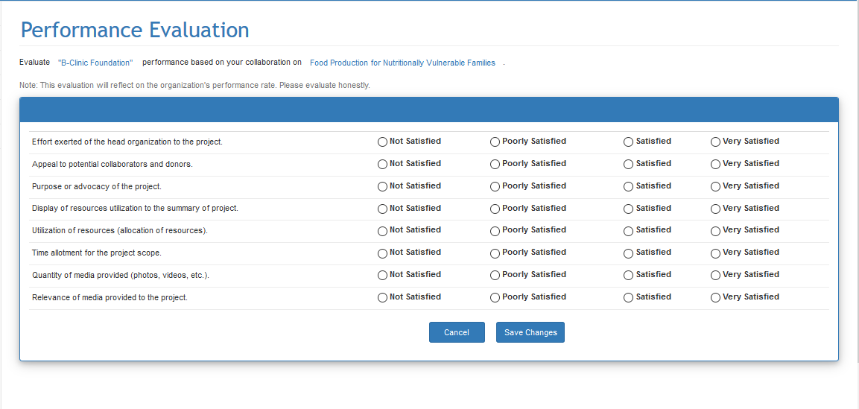

Figure 29. Evaluation Form Interface.

1. Performance Report

This module is for the registered users to check their overall performance on their projects or specific project. This interface contains a box that displays the overall performance of the organization and can be filtered by year. On the bottom part, it contains the specific finished projects within that year with their corresponding performance status. The interface also provides a link to each project for the users to see the details of how they got the result. Figure 30 shows the performance report interface of the application.

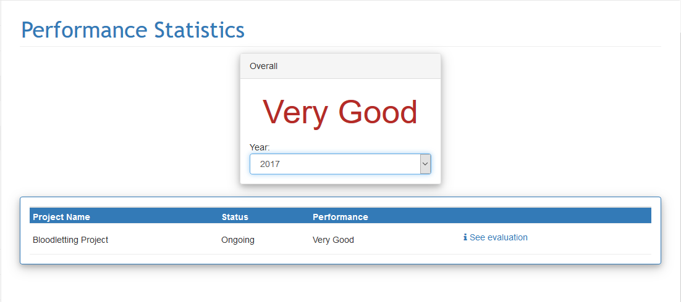

Figure 30. Performance Report Interface.

1. Create/Edit of Project Summary

This interface allows the users to create a summary report for a specific project of an organization. Users can add an activity name using the add icon situated at the right part of the interface just next to the discard icon. They can also select from the dropdown list for the needed resources with their corresponding quantities. The users can append additional resources through the use of the add icon beside the dropdown list. They can also choose to cancel or save the creation of the report using the buttons located at the lower right part of the interface. Figure 31 shows the Project Summary interface of the application.

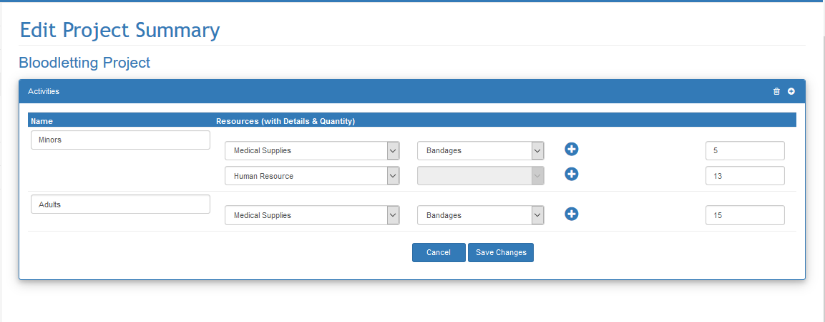

Figure 31. Create/Edit Project Summary Interface.

1. Summary Report

This interface allows users to see created summary report with regards to a certain project. The information presented in this interface is the project name, the start and end date, and the status. The users can open the summary details of a specific project through the use of the see summary situated next to the status of the project. The see summary is a link where users can click to view individual project summary. This interface displays the list of facilitated and collaborated projects of a particular organization. Figure 32 shows the Summary Report interface of the application.

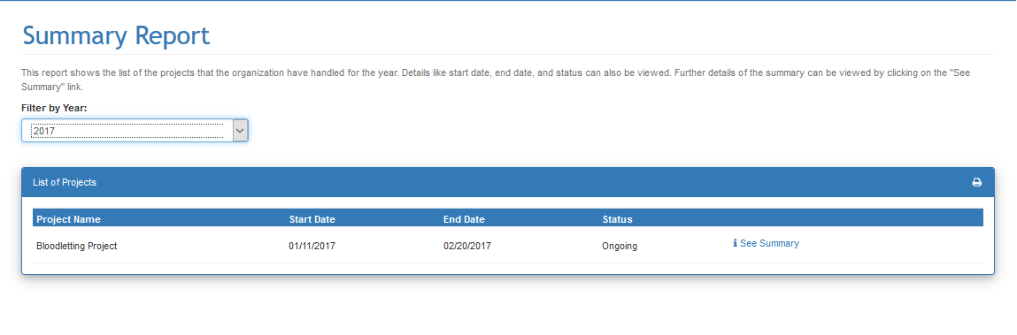

Figure 32. Summary Report Interface.

1. Evaluation Details

This interface is for the users of the application to check the evaluation details of how they got the evaluated performance. The interface displays the criteria where it got the highest evaluation score and lowest evaluation score. This is to show the strong and weak points of the organization during the project. The interface also displays the overall evaluation point of the organization. A legend representing the equivalent rating based on the overall score is also available in the interface. This serves as a decision supporting report for the organization to their future projects. Figure 33 shows the evaluation details interface of the application.

4.1.31

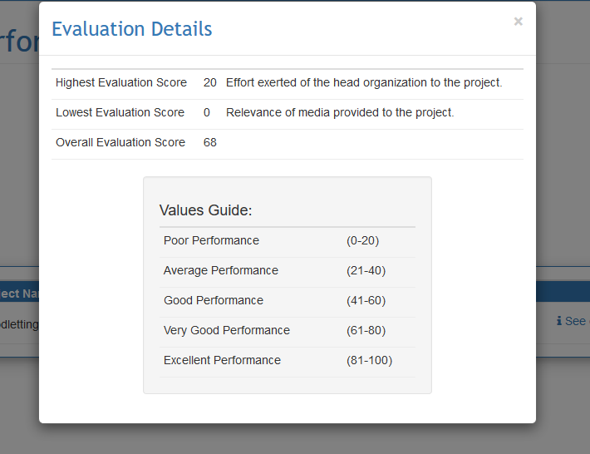

Figure 33. Evaluation Details Interface.

1. Project Summary Details

This interface displays the details of the summary of the project created by the organization or creator of the project. It shows the collaborators that donated in the project and their corresponding contributions. This is to show who donated and contributed to the project. It also displays the allocation of resources to the different activities that are encoded by the organization that created the project. The list is presented to give credit to the collaborators that donated and contributed to the project and to give justice to their donations. Figure 34 shows the project summary details interface of the application.

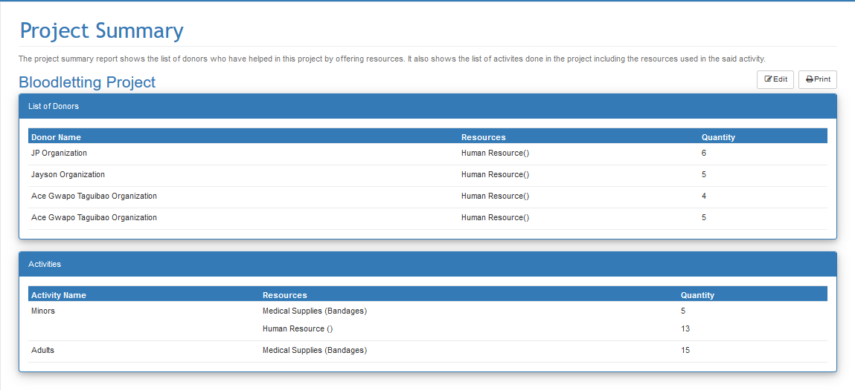

Figure 34. Project Summary Details Interface.

1. Hardware Interfaces

ASEAN Aid Map is a web application that does not require installation. The application is responsive to all screen resolutions which means that it can adapt to any device. As a web application, it requires a browser for it to run. An internet connection is also necessary for the application to work properly. The succeeding sections discuss the hardware interfaces of the application.

1. Desktop Computers/Laptop

The web application needs hardware devices that match the requirements given. Since the application retrieves different data from the server, it allocates a capacity in the physical memory. It requires an internet connection as well for the application to perform its functionalities. A better suggestion is to use Mozilla Firefox or Google Chrome as a browser because HTML5 is better to run in those browsers.

The web application runs on the browser of the device and does not require installation. Since it is a web application, it can run on any version of the different operating system as long as the gadget meets the minimum hardware requirements that the application requires. The Wi-Fi or any form of internet connection is also needed for the application to perform its functionalities correctly. It is better if the browser in the device is Mozilla Firefox or Google Chrome because HTML5 runs better in those browsers and they are free to download.

1. Software Interfaces

This section discusses how the application communicates with each other. It also explains the different software used in developing the application. The software provides access to the hardware that the application requires.

In coding the web application in the development, the proponents used JetBrains WebStorm as their editor for developing both the server-side and client-side functionalities and web pages. It provides developers with a user-friendly and easy-to-use environment in developing web applications using MEAN.JS solution. The proponents used MEAN.JS as a solution for developing the web server, database, and front-end functionalities. Figure 35 shows the interface of JetBrainsWebStorm.

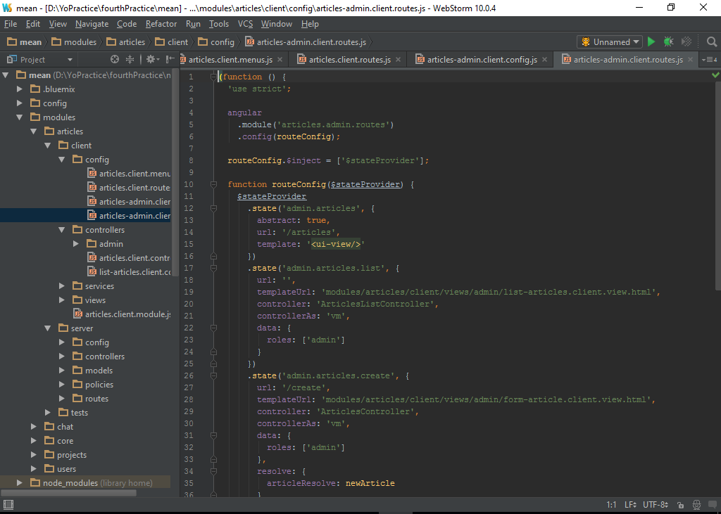

Figure 35. JetBrains WebStorm.

In designing the application’s interface, graphics, buttons, and menus, the group used Adobe Photoshop editor as their modeling tool. This tool helps the developers in making each interface pleasant to the eyes of the users. Adobe Photoshop editor helps the application design quality improved. It provides users with easy-to-use modeling functions that can help smoothen the designing of the buttons and interfaces of the application. In addition to this, the mastery level of the designer in the team is quite high in Adobe Photoshop CC compare to other modeling tools. Figure 36 shows the Adobe Photoshop interface.

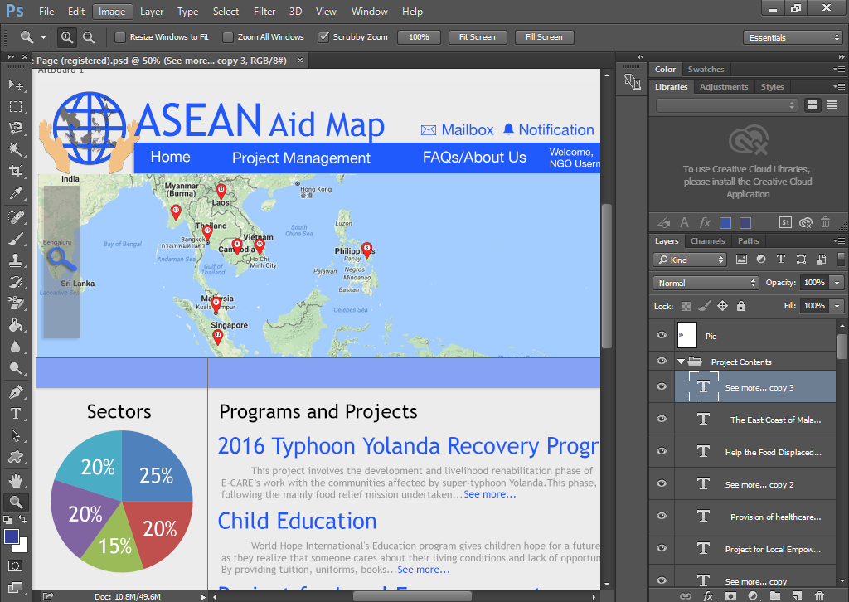

Figure 36. Adobe Photoshop CC.

4.4 Communication Interface

The proposed study is a web application that requires a web server to listen to the requests of the clients. The client communicates with the internet server for applications and storing data. The web server serves as the bridge between the client and the database. The server stores the data passed by the user to the database, as well as gather data from the database depending on the request of the user. The client issues different HTTP and socket requests and waits for the server to response to those requests. Figure 37 shows the communication between the client and the server.

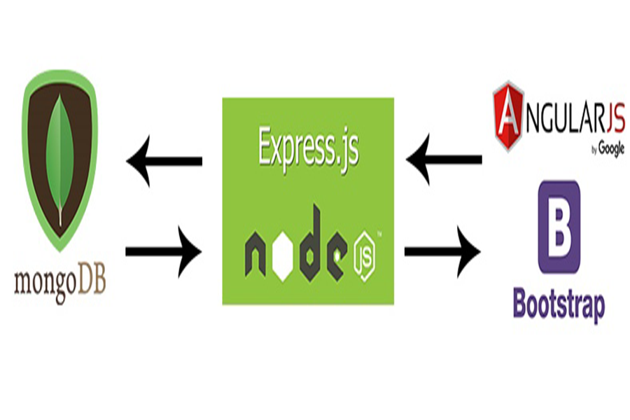

Figure 37. Communication Between Client and Server.

This chapter explained the different interfaces that the application contains. It discussed according to their relevance which is from user interfaces down to communication interfaces. It also includes the hardware and software that the application handles and how the protocols used by the application in its processes.